CS 255 System Design Document Template

UML Diagrams

UML Use Case Diagram
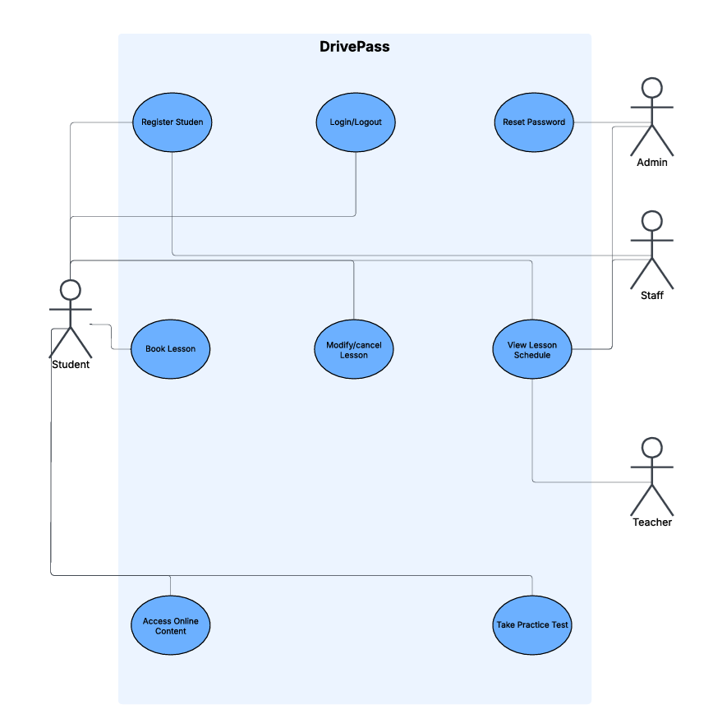

UML Activity Diagrams
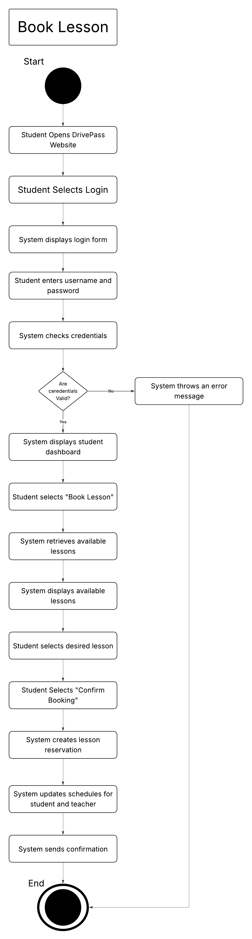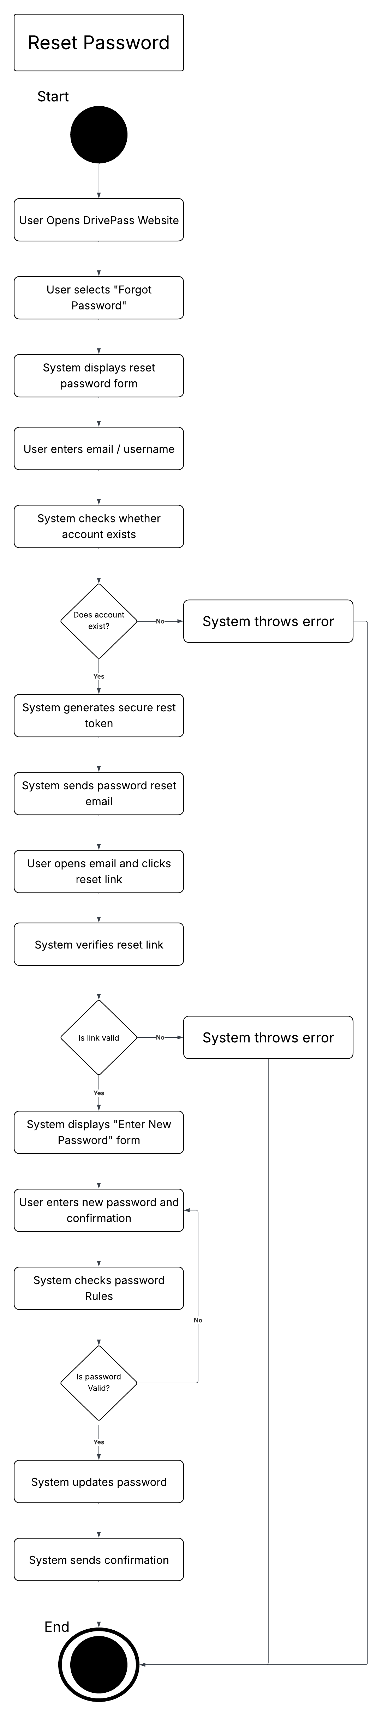

UML Sequence Diagram
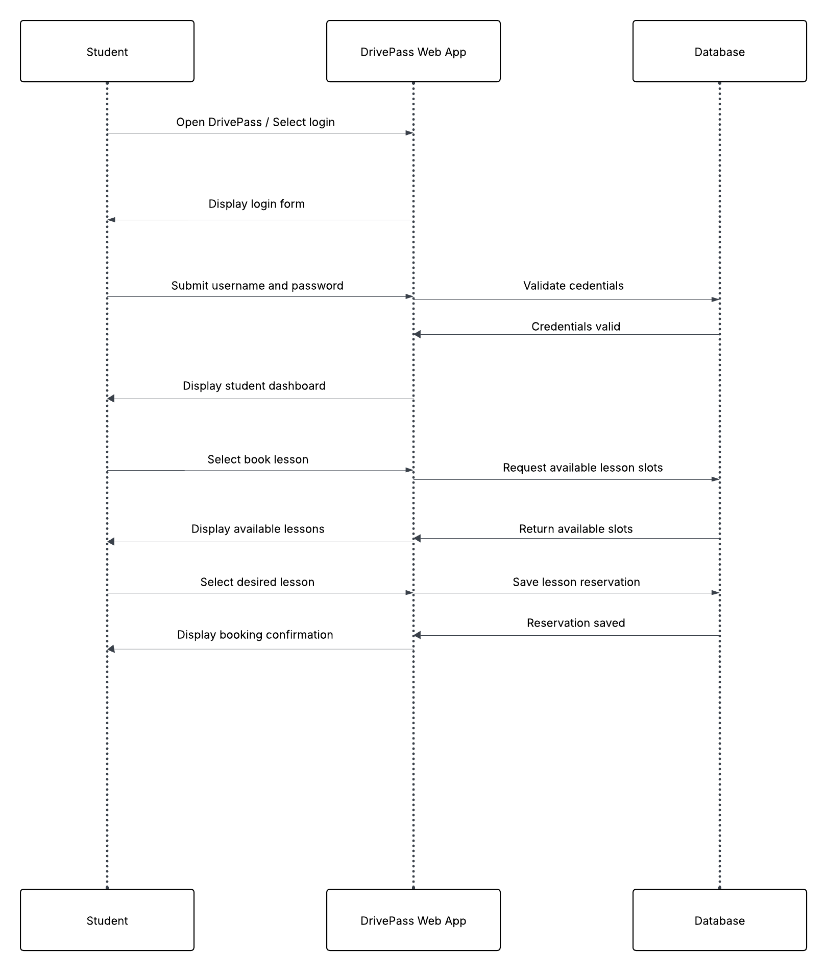

UML Class Diagram
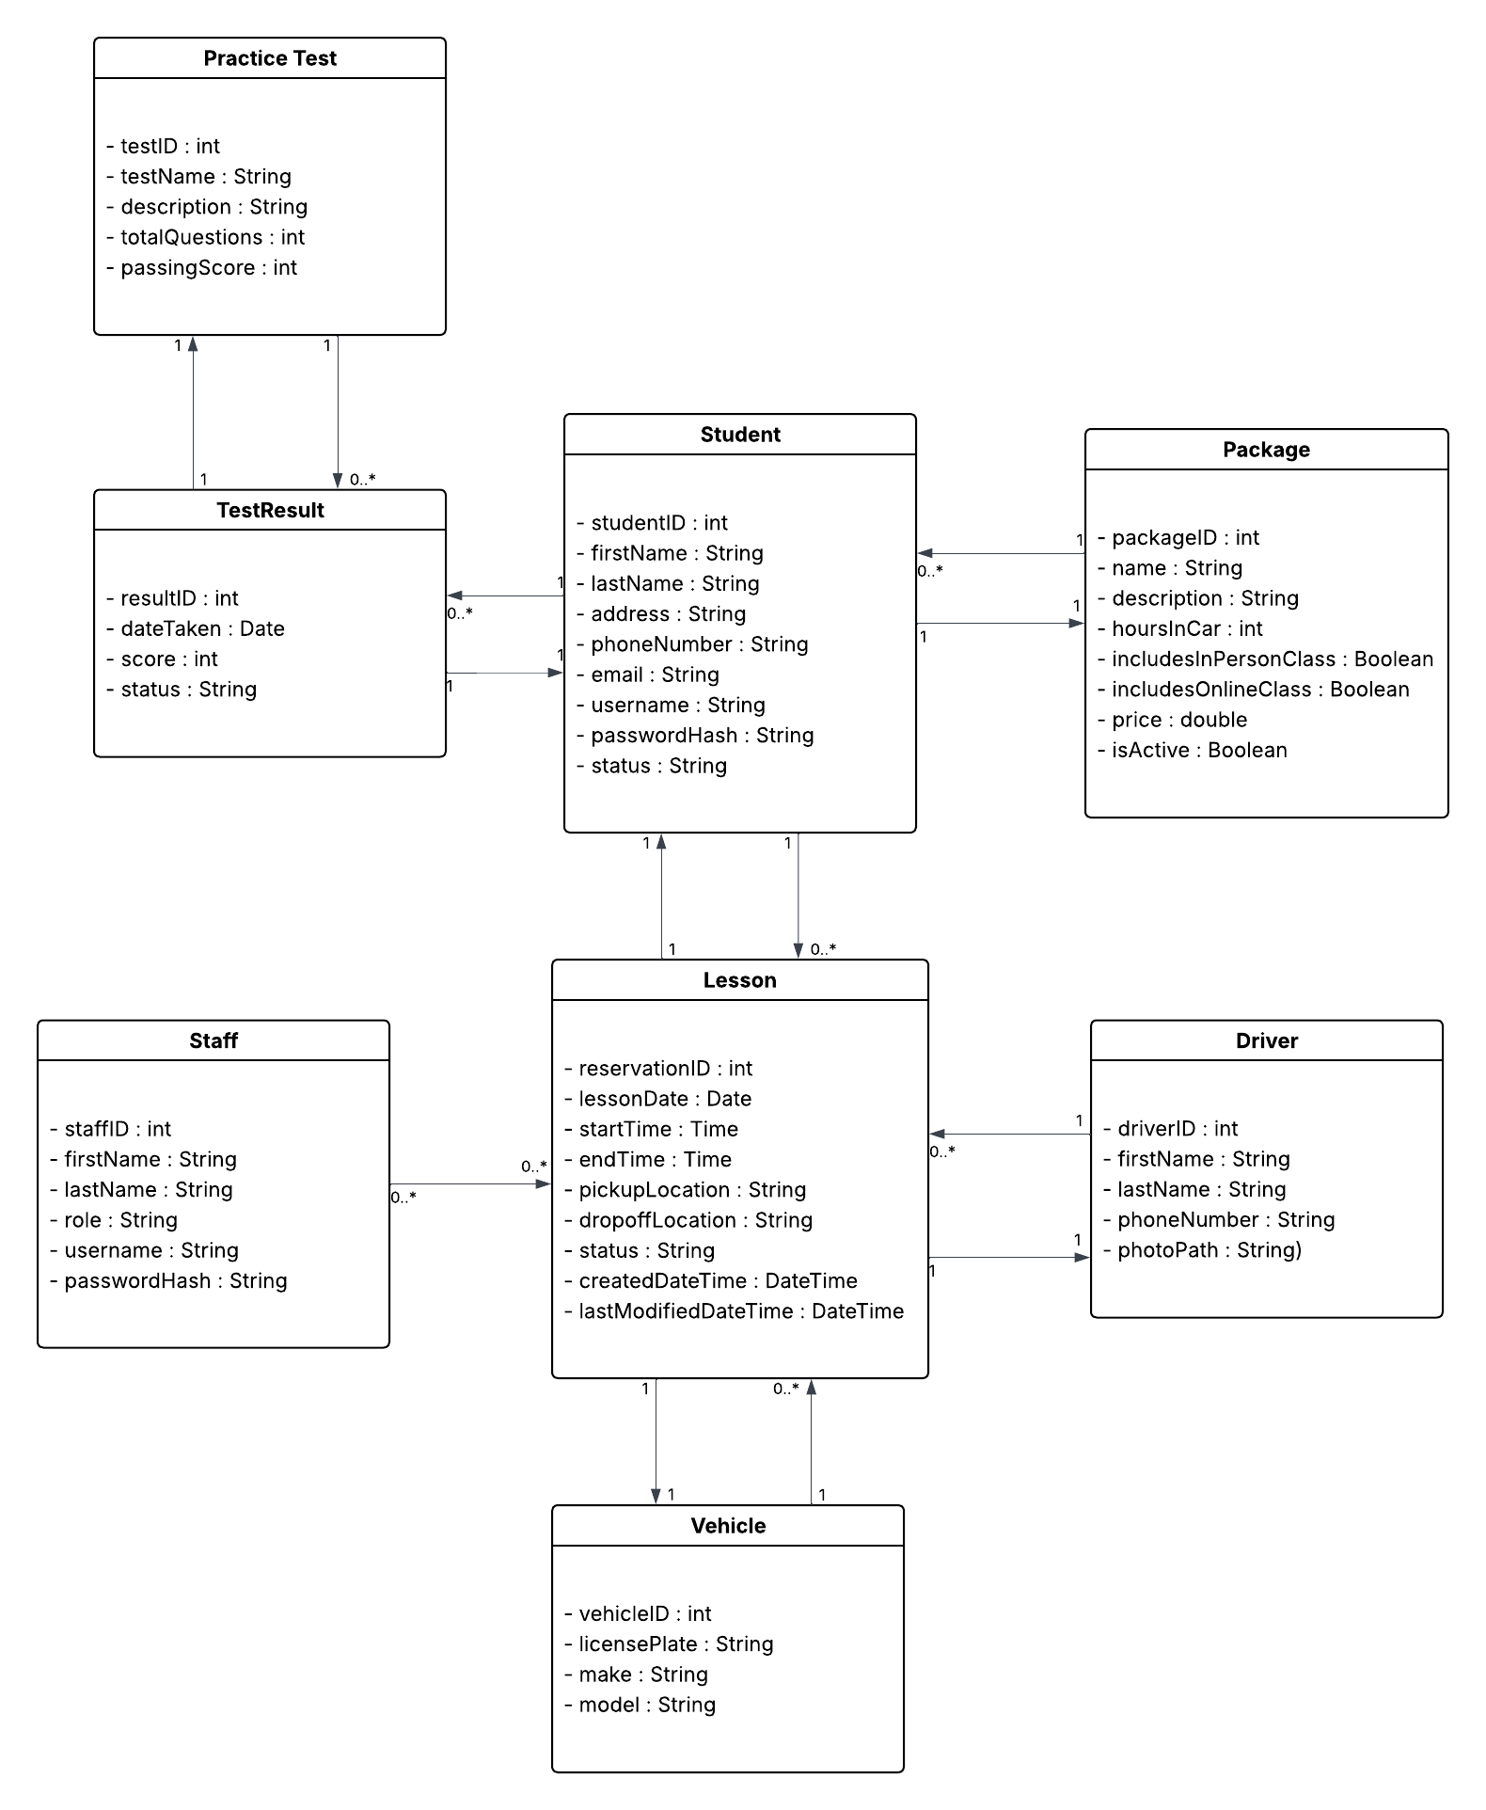

Technical Requirements
The DriverPass system will operate as a secure, cloud-based web application accessible to students, instructors, staff, and administrators from any modern device. The system must support stable, real-time access through common web browsers, including Chrome, Firefox, Safari, and Edge. Since the application must be usable across desktops, laptops, tablets, and smartphones, it requires a responsive user interface and reliable internet connectivity.
From an infrastructure standpoint, the system requires a cloud-hosted environment that includes a web server, an application server, and a relational database. The cloud provider will handle hardware provisioning, storage, automated backups, availability monitoring, and scalability. This ensures the system can handle peak usage periods when many students are scheduling lessons or completing online tests. All communication between users and the system must occur over HTTPS to maintain encryption and protect personal and sensitive information such as passwords, lesson history, and test results.
The software architecture must support user authentication, role-based access control, lesson scheduling logic, password reset workflows, secure storage of encrypted passwords, and DMV-sourced content updates. The backend requires a relational database management system to store users, roles, reservations, vehicles, instructors, test results, notes, and available packages. The scheduling subsystem must prevent double-booking and ensure that instructor, vehicle, and time slot availability are consistently maintained. The system must also send automated notifications for confirmations, cancellations, or password recovery.
Security requirements include encrypted password storage, session management, account lockout after repeated failed login attempts, and audit logging for all actions performed by staff or administrative users. IT personnel require specific administrative tools to reset user passwords, modify account permissions, and disable accounts when necessary. The system should support future enhancements, such as new training packages or additional reporting tools, without requiring major structural redesign.

